**How to add git hub credentials:**

* Go to manage Jenkins🡪 manage plugins 🡪search for credentials plugin

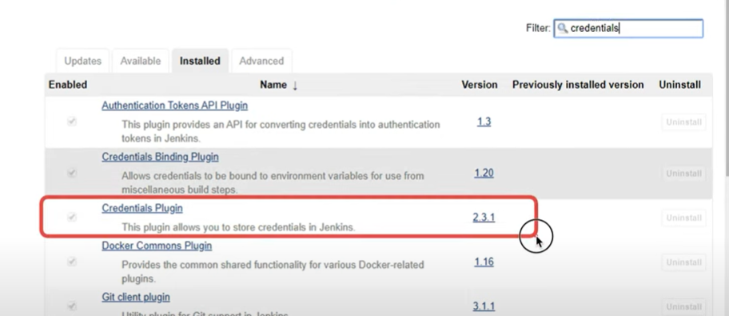

After you install above plugin then you will be able to see the credentials options in left panel.

Click on credentials🡪 Jenkins🡪 global credentials🡪 add credentials

Then you will see below window

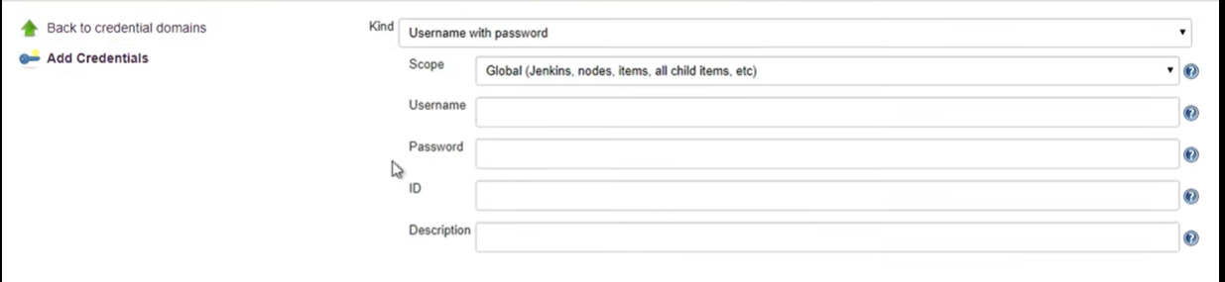

In description we need to tell about for which system we want to add credentials. Like we can add for github credentials.

Then give guthub username and password .

Don’t give anything in ID since it is auto generated.

Now you can edit those credentials as well.

Now we can use these credentials in jobs that we create.

**How to use catlight:**

Catlight is a status notifier for Jenkins. Catlight will notify you when builds, bugs & tasks need your attention.

Go to <https://catlight.io/>

From there you can download catlight for your operating system.

The symbol of catlight that gets appear on task bar of your desktop is below:

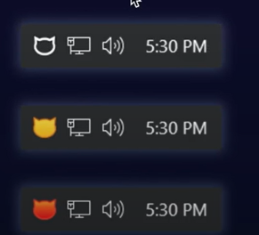

In catlight settings you need to provide the URL of Jenkins. Also select what all project you want to get notified for.

Now when you trigger any job from Jenkins then a notification will get popup on your screen.